Exercise 1

**Create and Manage Azure Machine Learning workspaces in the Azure portal**

**APPLIES TO:** yesBasic edition yesEnterprise edition

In this article, you'll create, view, and delete [**Azure Machine Learning workspaces**](https://docs.microsoft.com/en-us/azure/machine-learning/concept-workspace) in the Azure portal for [Azure Machine Learning](https://docs.microsoft.com/en-us/azure/machine-learning/overview-what-is-azure-ml). The portal is the easiest way to get started with workspaces but as your needs change or requirements for automation increase you can also create and delete workspaces [using the CLI](https://docs.microsoft.com/en-us/azure/machine-learning/reference-azure-machine-learning-cli), [with Python code](https://docs.microsoft.com/python/api/overview/azure/ml/intro?view=azure-ml-py) or [via the VS Code extension](https://docs.microsoft.com/en-us/azure/machine-learning/tutorial-setup-vscode-extension).

**Create a workspace**

To create a workspace, you need an Azure subscription. If you don’t have an Azure subscription, create a free account before you begin. Try the [free or paid version of Azure Machine Learning](https://aka.ms/AMLFree) today.

1. Sign in to the [Azure portal](https://portal.azure.com/) by using the credentials for your Azure subscription.
2. In the upper-left corner of Azure portal, select **+ Create a resource**.



1. Use the search bar to find **Machine Learning**.
2. Select **Machine Learning**.
3. In the **Machine Learning** pane, select **Create** to begin.
4. Provide the following information to configure your new workspace:

| **Field** | **Description** |
| --- | --- |
| Workspace name | Enter a unique name that identifies your workspace. In this example, we use **docs-ws**. Names must be unique across the resource group. Use a name that's easy to recall and to differentiate from workspaces created by others. |
| Subscription | Select the Azure subscription that you want to use. |
| Resource group | Use an existing resource group in your subscription or enter a name to create a new resource group. A resource group holds related resources for an Azure solution. In this example, we use **docs-aml**. |
| Location | Select the location closest to your users and the data resources to create your workspace. |
| Workspace edition | Select **Basic** or **Enterprise**. This workspace edition determines the features to which you’ll have access and pricing. Learn more about [Basic and Enterprise edition offerings](https://docs.microsoft.com/en-us/azure/machine-learning/overview-what-is-azure-ml#sku). |

1. 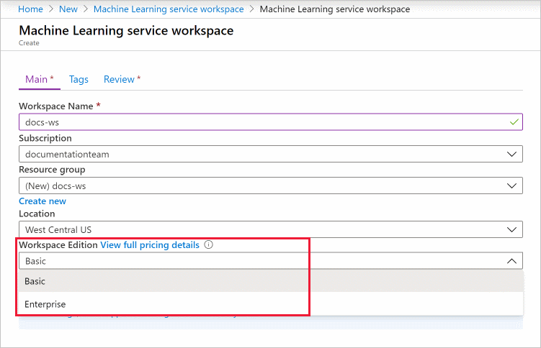
2. After you are finished configuring the workspace, select **Create**.

**Warning**

It can take several minutes to create your workspace in the cloud.

When the process is finished, a deployment success message appears.

1. To view the new workspace, select **Go to resource**.

**Download a configuration file**

1. If you will be creating a [compute instance](https://docs.microsoft.com/en-us/azure/machine-learning/tutorial-1st-experiment-sdk-setup#azure), skip this step.
2. If you plan to use code on your local environment that references this workspace, select **Download config.json** from the **Overview** section of the workspace.

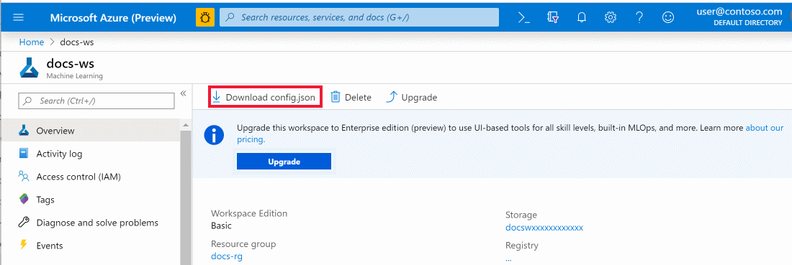

Place the file into the directory structure with your Python scripts or Jupyter Notebooks. It can be in the same directory, a subdirectory named *.azureml*, or in a parent directory. When you create a compute instance, this file is added to the correct directory on the VM for you.

**Upgrade to Enterprise edition – Please upgrade to access the designer and Automl GUI.**

You can upgrade your workspace from Basic edition to Enterprise edition to take advantage of the enhanced features such as low-code experiences and enhanced security features.

1. Sign in to [Azure Machine Learning studio](https://ml.azure.com/) or click the Launch arrow from the portal where it says “**Try New machine Learning studio”**
2. Select the workspace that you wish to **upgrade**.
3. Select **Learn more** at the top right of the page and click the upgrade to remove the green locks.

[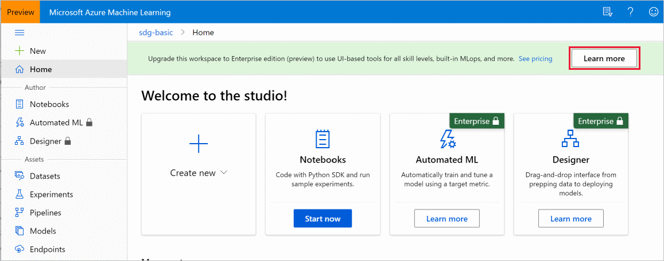](https://docs.microsoft.com/en-us/azure/machine-learning/media/how-to-manage-workspace/upgrade.png#lightbox)

1. Select **Upgrade** in the window that appears.

**Important**

You cannot downgrade an Enterprise edition workspace to a Basic edition workspace.

**Find a workspace**

1. In the top search field, type **Machine Learning**.
2. Select **Machine Learning**.

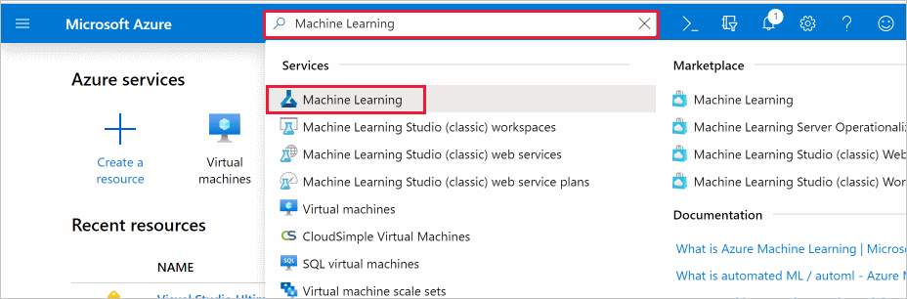

1. Look through the list of workspaces found. You can filter based on subscription, resource groups, and locations.
2. Select a workspace to display its properties.

**Add a compute resource**

Go to left hand side of panel and under Manage select compute.

1. Fill in name for the compute resource
2. Select default or a larger machine if desired DS3_V2.
3. Select **create**

**Delete a workspace – do not do this while in class**

Use the Delete button at the top of the workspace you wish to delete.

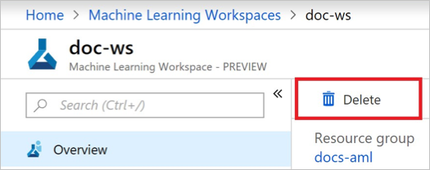

**Clean up resources**

**Important**

The resources you created can be used as prerequisites to other Azure Machine Learning tutorials and how-to articles.

If you don't plan to use the resources you created, delete them, so you don't incur any charges:

1. In the Azure portal, select **Resource groups** on the far left.

[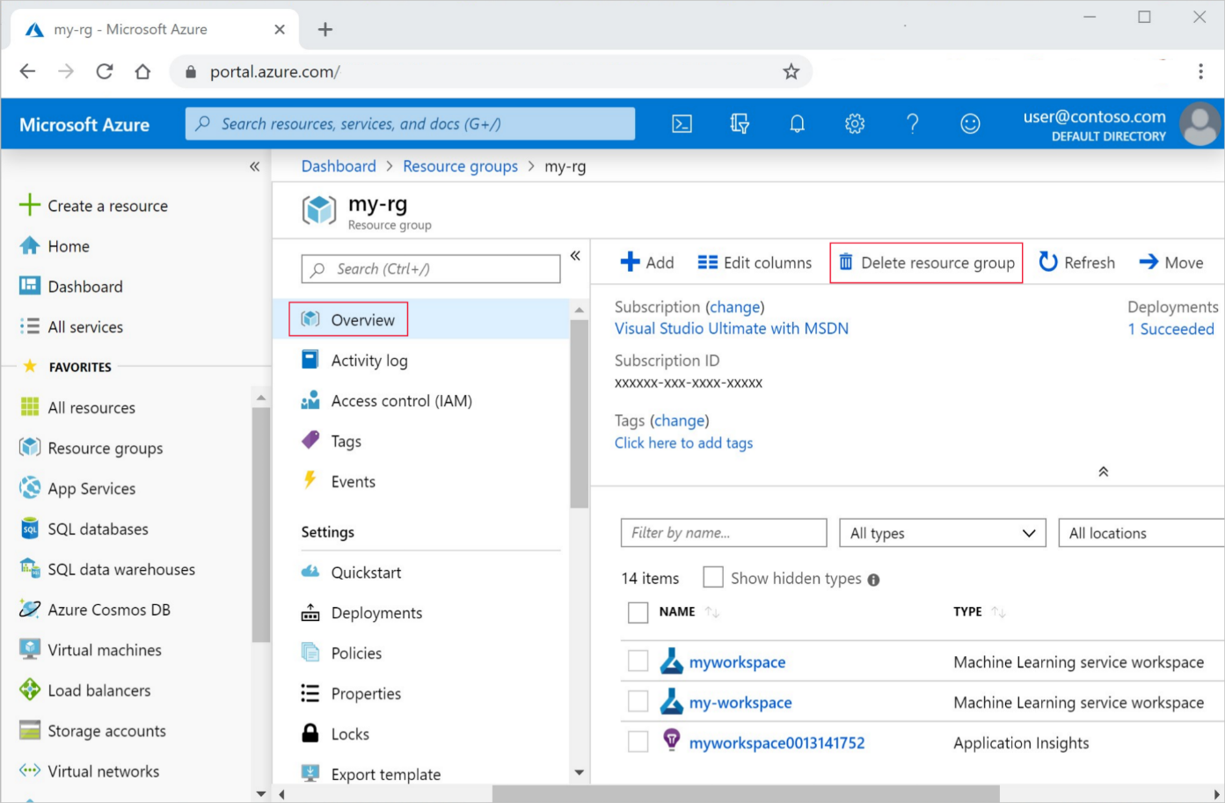](https://docs.microsoft.com/en-us/azure/includes/media/aml-delete-resource-group/delete-resources-expanded.png)

1. From the list, select the resource group you created.
2. Select **Delete resource group**.
3. Enter the resource group name. Then select **Delete**.

**Troubleshooting**

**Resource provider errors**

When creating an Azure Machine Learning workspace, or a resource used by the workspace, you may receive an error similar to the following messages:

* No registered resource provider found for location {location}
* The subscription is not registered to use namespace {resource-provider-namespace}

Most resource providers are automatically registered, but not all. If you receive this message, you need to register the provider mentioned.

For information on registering resource providers, see [Resolve errors for resource provider registration](https://docs.microsoft.com/en-us/azure/azure-resource-manager/templates/error-register-resource-provider).